Andong Yan

3/7/2017

Prof. Jeff Nugent

Econ 541: Term Paper Proposal

Research Proposal[1]

*Question: Find historical statistics on an emerging stock market (or any stock market in a developing country). Identify relevant rules under which the market has operated over time and possible changes therein. What are the institutional constraints on the development of this market? What policy recommendations would you make to limit these constraints and why?*

1. **Motivation**

Peter Blair Henry states in his papers that “stock market liberalization may reduce the liberalizing country’s cost of equity capital”, and he further points out that such prediction have two implications: first is people should observe “an increase in a country’s equity price index”, and second is “an increase in physical investment following a stock market liberations” (Henry 1999). From a policymaker’s point of view, these two implications are attractive features for a state since, theoretically, more physical investment will result in a higher economics output equilibrium, and increasing equity price index is usually referred to a phenomenon of the economy boom in common sense. However, despite the promising advantages of stock market liberalization, almost forty years have passed since its successful economic reform, the Chinese government has not fully lifted its restrict on stock market capitals yet. It is interesting to discuss whether the Chinese government is reluctant to implement a full stock market liberalization and what potential outcomes will be if such a liberalization comes such.

1. **Background**

Peter Henry (Henry 1999) conducts from a sample of 11 emerging capital markets that market liberalizations lead private investment boom. Many developing countries liberalized their capital markets in the late 1980s and early 1990s, and from 11 selected markets, their mean growth rate of private investment jumped high by 22 percentage points, and most of them remained an abnormal higher growth rate of private investment in the following three years after liberalization (Henry 1999). Meanwhile, China experienced a phenomenal high growth rate of the economy during the same period, but its foreign capital inflow remained restricted for a long time. By May 2015, China’s stock market was worth over $10 trillion, around a quarter of world market cap; in contrast of the huge capital volume, several policies like Qualified Foreign Institutional Investor (QFII) Scheme and RMB Qualified Foreign Institutional Investor (RQFII) Scheme only relieved the restraints on foreign capital investment in China’s domestic markets, but a complete market capital liberalization is still not expected to happen.

Many potential reasons may explain why China’s government does not stop its regulation: first, government regulates the inflow and outflow capitals strictly due to its desire for a stable currency rate. Not only the stock market has many restraints, Chinese currency market is also under government’s control. Since government wants to maintain a stable currency rate, it cannot allow a huge amount of foreign capital inflow that brings an appreciation in RMB and deteriorates export. Second, the economy fluctuation might actually stop the liberalization process. Back to 2015, it used to be news about a deeper liberalization would happen when Chinese stock market started its latest boom. Unfortunately, in June 2015, the stock market collapsed and the index fell from peak over 5000 points to almost half of it. The huge fluctuation could prevent the policymakers implementing further liberalization but start to stabilize the stock market. Third, previous literature (Chen and Shen 2012) shows that QFII did not work well in improving domestic private investment. This fact might let Chinese policymakers less confident in the positive effect that capital liberalization could bring to the market. I will try to cover as many as possible papers and news about Chinese foreign capital policies to conclude a model that can properly describe the liberalization effect on capital markets.

1. **Model, Data, and Plan**

Following many previous researches, I will first construct my model on capital market performance with dependent variables such as policy changes, business cycles, domestic fundamentals, etc. Hence I could test the effects of previous Chinese liberalization policies. Besides Chinese market, I will collect data from other developing countries which used to implement a capital liberalization and construct a model that could estimate the full liberalization effects on their economy and use this model to predict such liberalization effect in the case of Chinese capital market. Based on my study, I understand that a synthetic control method might work well in this case to eliminate other unobserved variable that might cause potential biases. Thus I will try to implement this method as well as standard panel data method to compare the results.

For data, I will search on world bank database, Chinese government’s website, Yahoo’s finance website and other available sources to conduct my own database to conduct my analyses.

I will organize my paper in such way: Section I introduces the issue and briefly discuss my findings; Section II discusses the previous literature and describes the specific background of Chinese stock market and related polices; Section III explains my model and how I conducted my database. I expect to finish these three sections in the second short paper if Prof. Nugent grants allowance. Next, Section IV will display the effect of previous partial-liberalization policies by the Chinese government; Section V shows the result from other countries’ liberalization events and makes my prediction on China’s stock market liberalization and Section VI will give my policy suggestions and conclude the paper.

1. **Bibliography[2]**

Diversification in the Chinese Stock Market, 2003

Do stock market liberalizations cause investment booms?, 1999

Financial liberalisation and international market interdependence: Evidence from China’s stock market in the post-WTO accession period, 2014

Impacts of the Stock Market Liberalization in China: Evidence from the Foreign Institutional Investor Scheme, 2012

Stock Market Liberalization and Market Returns in China: Evidence from QFII Announcement

The Chinese Stock Market: Development and Prospects, 2004

The efficiency of the Chinese stock market and the role of market liberalization, 2010

The Internationalization of the RMB, Capital Market Openness, and Financial Reforms in China, 2015

The Real Value of China’s Stock Market, 2015

1. **List of the 12 emerging markets**

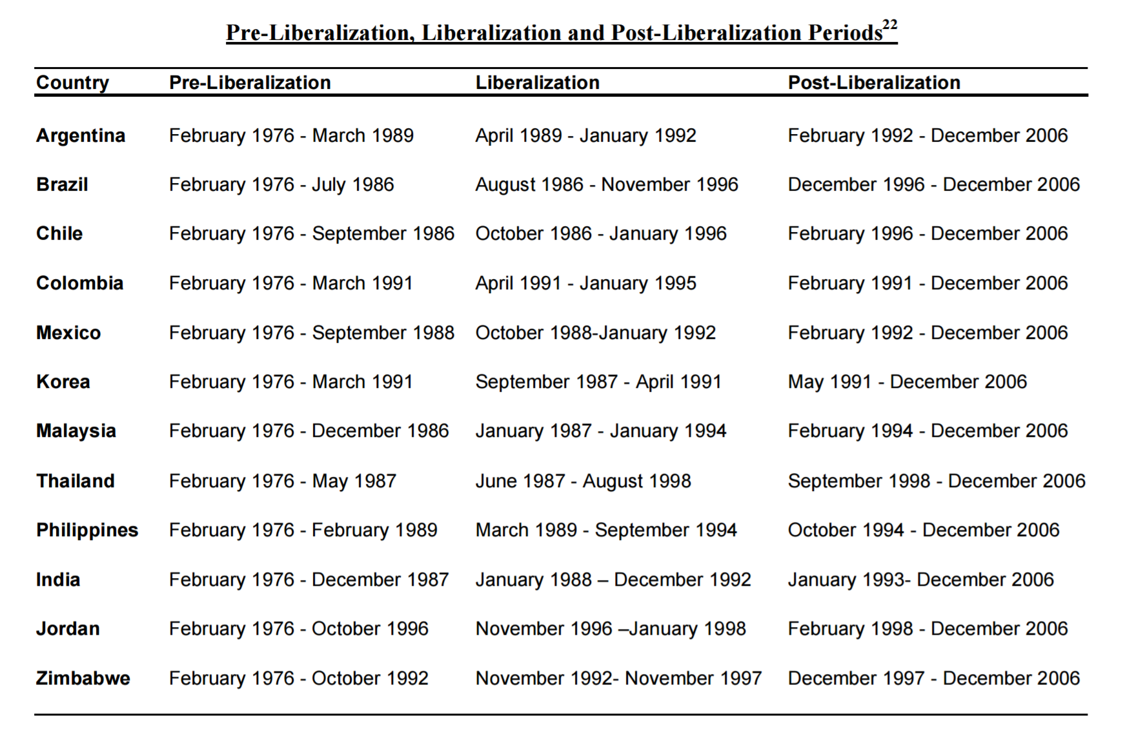

1. Due to lack of time, I did not make citations to the authors I refer in the essay. I leave all the papers I have read and will read and refer in the bibliography section. Sorry for the inconvenience.
2. Here I only list the title of the papers due to lack of time. I expect the list to grow a lot when the paper is finished.